**Sampling strategy MAR oscillations Experiment**

**Reactor Setup:**

Reactors will be set up as shown in the figure below. Three treatments will be run using only the 05A transect soil collected from the Kelly Thompson Managed Aquifer Recharge (MAR) basin in Sept. 2021. Each reactor will be run in triplicate. The treatments will be as follows:

1. Soil and synthetic stormwater
2. Soil and synthetic stormwater spiked with nitrate
3. Soil and synthetic stormwater spiked with nitrate with woodchips (in carbon teabag)

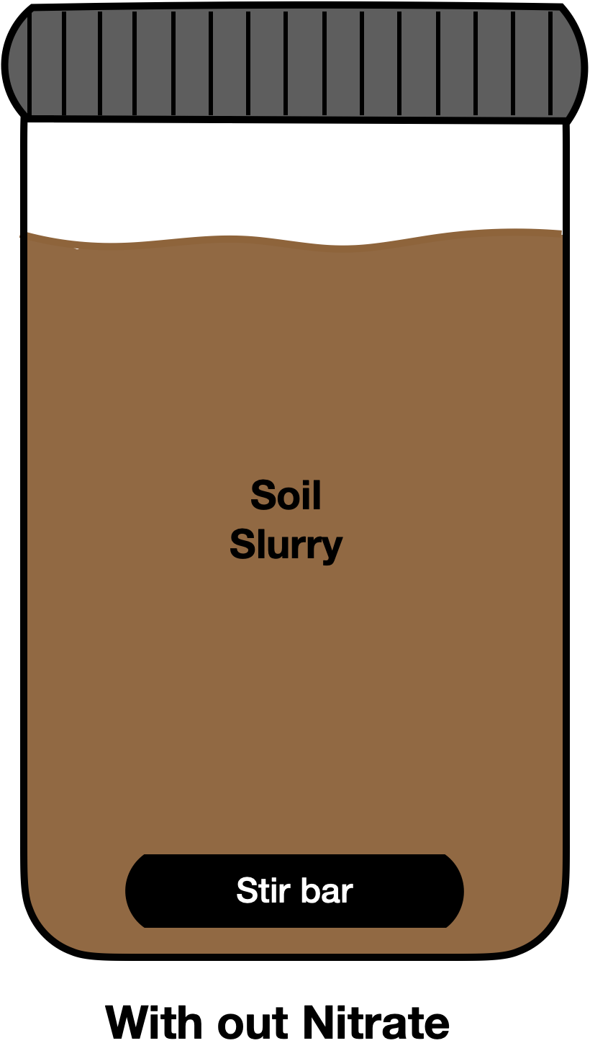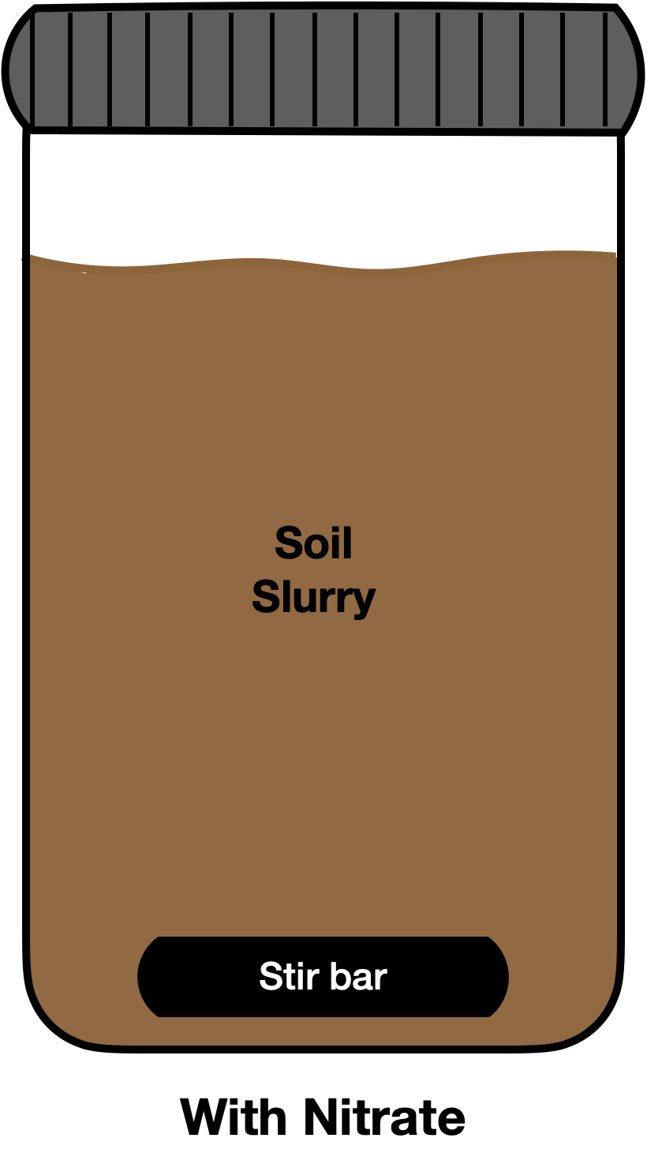

**With nitrate and WC**



Repeated redox

cycling



Carbon Teabag

**Suspension Ratio:**

Reactors will be run with a solid to liquid ratio of 1:10 as was done in Barcellos et al. (2018). I think that we said we wanted 750 mL of liquid in the reactor, so we can add 75 g of soil to 750 mL of synthetic stormwater for each reactor. Record final soil masses for each reactor.

**Specifics of Synthetic Groundwater:**

1. Synthetic stormwater: <https://pubs.acs.org/doi/10.1021/es5033162>
2. Nitrate levels (**Only none and low for this experiment)**:
   1. None: 0 mg/L
   2. Low – 20 mg/L nitrate (added as KNO3). Set to match the inflow water to the MAR basin (inflow data:<https://docs.google.com/spreadsheets/d/1Z25CvT5Z8RMXa2EinMbQsMXgcojfxCLaU_ahX3cra70/edit#gid=129263458>). Inflow at KT_04A_00 was 4.178 mg NO3-N → corrected to NO3- it was 18.4951. Rounded up to 20 mg/L as a nice whole number.
   3. High – yet to be determined and not needed for this round of the experiment.

**Soil Preparation and Characterization:**

1. **Soil preparation** – homogenize soil in glove bag. Do this in a large bin or bag. Pull homogenized soil from this bin for preparation of reactors and all soil characterization methods outlined below.
2. **Soil Characterization**:
   1. Laser particle size analysis – Protocol from Andy Gray’s lab
   2. Native carbon measurements
      1. Water Extractable Organic Carbon (Homyak et al. 2018)
      2. Total Carbon and Nitrogen (EA down in the EDGE institute)
   3. Soil mineralogy – XRD
   4. Soil pH (Slurry method)
   5. Total metal concentration (XRF or Microwave digestion)
   6. 7 Step sequential extraction procedure (iron phase specific – Poulton and Canfield)

**Experimental and Sampling Timeline:**

The experiment will be run for at least 1 full anoxic-oxic cycle, possibly 2 if we have time. A full cycle consists of 7 days anoxic + 7 day oxic. Half cycles will be 7 days either oxic or anoxic. Sampling will begin from the start of each full cycle and will be conducted as outlined in the below table.

|  |  |  |  |  |  |  |  |
| --- | --- | --- | --- | --- | --- | --- | --- |
| **Sampling time** | **DOC?**  **(20 ml filtered)** | **Nitrate, ammonia, & phosphate**  **(2 ml filtered)** | **Dissolved Metals**  **(5 ml filtered)** | **Arsenic Speciation (2 ml slurry or filtered?)** | **HCl extractable Fe (II) (1.5 mL slurry)** | **HCl extractable Mn (II) (1.5 mL slurry)** | **Solid Phase XAS sampling (1 filter)** |
| Day 0 (0 hrs.) | Yes | Yes | Yes | Yes | Yes | Yes | Yes |
| Day 1 (24 hrs.) | Yes | Yes | Yes | Yes | Yes | Yes | Yes |
| Day 2 (48 hrs.) | Yes | Yes | Yes | Yes | Yes | Yes | Yes |
| Day 3 (72 hrs.) | Yes | Yes | Yes | Yes | Yes | Yes | Yes |
| Day 5 (120 hrs.) | Yes | Yes | Yes | Yes | Yes | Yes | Yes |
| Day 7 (168 hrs.) | Yes | Yes | Yes | Yes | Yes | Yes | Yes |
| Day 8 (192 hrs.) | Yes | Yes | Yes | Yes | Yes | Yes | Yes |
| Day 9 (216 hrs.) | Yes | Yes | Yes | Yes | Yes | Yes | Yes |
| Day 10 (240 hrs.) | Yes | Yes | Yes | Yes | Yes | Yes | Yes |
| Day 12 (288 hrs.) | Yes | Yes | Yes | Yes | Yes | Yes | Yes |
| Day 14 (336 hrs.) | Yes | Yes | Yes | Yes | Yes | Yes | Yes |

Table Key:

Green = Oxic half-cycle

Red = Anoxic half-cycle

**Aqueous phase sampling and volume:**

1. DOC and DON → 25 ml filtered and stored in fridge for no more than 1 week. 2 mL taken for analysis on AQ2.
   1. Method: No specific method, just how we run DOC.
2. Nitrate, ammonia, and phosphate (AQ2) → 2 ml (need specifics – I would guess filtered through. Pull 2 mL from the extra in the DOC sampling.)
   1. Method: Filter samples and aliquot into 2 mL mini centrifuge tubes.
3. Dissolved metals → 5 ml filtered and acidified (HCl) for ICP (Mn, Fe, As, Ca, K, Na, any others?)
   1. Method: Just remeasure volumes due to loss from filter and acidify (3% nitric?).
4. Arsenic Speciation → 2 – 5 ml
   1. Method: Hydride Generation – Do we have a method for this?
5. HCl extractable Fe(II) → 2 mL slurry
   1. Method: Protocol – 0.5 M HCl Extraction (to measure FeII by ferrozine) followed by the Thompson Lab Ferrozine (Colorimetric) measurement of extractable Fe(II)
      1. See Lab SOPs folder and add to methods folder on google doc.

**Solid phase sampling:**

At every sampling point we will also collect a solid phase sample for XAS at SSRL. This will be done as explained below in the sampling protocol section of the document.

**Other Measurements**

1. DO – every day that we sample and during purging.
2. pH – every day that we sample

**Procedure for Transitioning from Oxic to Anoxic**

The following procedure will be use to transition reactors from oxic to anoxic, and reactors will be bubbled with N2 gas 6 at a time.

1. Place parafilm halfway over the top of the reactor. This will eventually be used to temporarily seal the reactor after oxygen has been purged.
2. Place one of the 6 N2 hoses into the slurry. Repeat for the rest of the reactors
3. Using one of the pH meter stands, place the calibrated DO probe into one of the reactors. We will need to record DO concentrations at standard intervals during N2 purging to insure that the reactors are being purged of oxygen and we are indeed inducing reducing conditions (to be additionally confirmed with Fe(II) measurements).
4. Turn on the N2 gas and ensure that there is a solid bubbling occurring in all reactors. (Still need to determine if it is better to do this while the reactor is being mixed on a stir plate? N2 bubbling does mix the solution reasonably well on its own without a stir plate being necessary.)
5. Record DO measurements every 2 minutes until reactors have stabilized at a low oxygen concentration (probably about 15 minutes in total).
6. Cover all reactors over with their parafilm leaving only a small gap for the N2 hose. Purge for another minute, then as long as the oxygen concentration stays constant, pull the N2 hose, seal the parafilm, and place the lid on the container.
7. Immediately transfer all 6 reactors into the glove bag. Now we are ready to begin the first sampling point on the first 6 reactors. Probably makes sense to sample these before purging the remaining reactors.

**Procedure for Transitioning from Anoxic to Oxic**

Reactors will be transitioned from anoxic to oxic by the following procedure.

1. Pull 6 reactors out of the glove bag.
2. Uncover each reactor and place onto a stir plate.
3. Again, place the calibrated DO probe into one of the reactors
4. Turn the stir plates on and ensure that reactors are mixing well, and all sediment is suspended.
5. Record DO measurements every 2 minutes until reactors are saturated with oxygen.
6. Allow to equilibrate for 90 minutes
7. Take DO and pH again
8. Ready to sample

**Sampling Procedure (on the bench when oxic and in the glove bag when anoxic).**

1. Check and record the DO concentration and the pH of each reactor before beginning sampling.
2. Ensure that reactors are really well mixed and that all sediment is suspended. On the bench they should be ok since they will be mixing on the stir plates. In the glove bag you will need to cap them (if not already) and give them a really good shake before sampling.
3. Going through the reactors one at a time, conduct the following sampling
   * 1. HCl Extractable Fe(II) sampling – following the procedure followed in Barcellos et al. (2018) – see methods folder in google drive.
        1. Withdraw 0.5 mL of slurry
        2. Add 1.0 mL of 0.75 M HCl, i.e., suspending 0.05 g (dry weight equivalent) of the sample in 1.5 mL of 0.5 M HCl.
        3. The suspension was then shaken for 2 h on a horizontal shaker (this must be done in the glove bag/anoxic container for anoxic sampling days).
        4. Centrifuge at 11,000 rcf (relative centrifugal force) for 10 min (We will have to do this with our mini centrifuge, I am not sure how fast that thing actually goes, but we have sandy soils, so I would imagine that solids will settle out pretty fast).
        5. The supernatant will be carefully removed and analyzed for Fe(II) following the Thompson Lab Ferrozine (Colorimetric) measurement of extractable Fe(II) – See methods folder on google docs for protocol.
   1. Solid phase sampling
      1. Draw approximately 4-5 mL of slurry using a syringe.
      2. Attach the syringe to the appropriate reusable syringe filter with a fresh 0.20 um filter paper.
      3. Filter the solution (discarding the filtrate) and store the filter paper in a labeled petri dish in the desiccator if it is an oxic sampling, or the glove bag if it is anoxic.
      4. Repeat for all reactors.
   2. Sampling DOC and nitrates, ammonia, and phosphate.
      1. Using a 12 mL syringe draw a full syringe of slurry.
      2. Filter the solution through a single use 0.22 um luer lock syringe filter into a pre-labeled 50 mL centrifuge tube.
      3. Repeat a second time so that you have approximately 13 -15 mL of filtered solution.
      4. Store in the dark in the fridge. Eventually 2 mL sample will be pipetted into a 2 mL centrifuge tube for AQ2 and 10 mL of sample will be diluted 1:1 in DI water to be run for TOC/TON on the Shimadzu.
      5. Next move on to the sampling for metals and solid phase.
   3. Sampling for aqueous metals
      1. Aqueous metals + As speciation
         1. Draw approximately 8.5 mL of suspension using a 12 mL syringe.
         2. Filter the solution through a single use 0.22 um syringe filter.
         3. The filtered solution is now ready to be aliquoted and acidified for ICP.
         4. Take 5 mL of solution and bring to 3% nitric acid in a separate tube. This will be used for ICP. Add 230 uL of concentrated nitric acid to the 5 mL of sample. Store in the fridge for ICP analysis.
         5. Pull 2 mL of solution and store in a second tube in the glove bag. This will eventually be used for hydride generation to measure arsenic speciation.

**Experimental Breakdown**

1. Sample for 16s 🡪 Then freeze at -80.
   1. Stop all reactors and allow solids to settle at the bottom (approximately 10 minutes)
   2. Using a sterilized (70 % ethanol washed) scoopula take 2 – 3 scoops (2-5 g solid WW) and transfer into the appropriately labeled sterile (orange cap) centrifuge tube.
   3. Immediately place tube on dry ice.
   4. Repeat for other reactors, sterilizing the scoopula in between treatments and replicates.
   5. Once done sampling, transfer all tubes to the -80 C freezer on the 3rd floor of SciLabs for storage.
   6. Then get all the reactors spinning again!
2. Measure pH and DO in all reactors.
3. Draw slurry for HCl extractable Fe(II) for all reactors.
4. Vacuum filter all samples by the following procedure:
   1. Using a vacuum filtration system, filter reactors one at a time through a 0.25 um filter.
   2. Solid preservation (XAS, sequential extractions, total C and N, PSA, and XRD)
      1. Take out filter with solid after filtering and set out on the plastic side of clean bench top paper. Make sure to label which filter you are putting where!
      2. Cover with another piece of benchtop paper and allow to dry for 36 - 48 hours.
      3. On Monday, transfer to labeled centrifuge tubes and petri dishes as follows:
         1. For XAS 🡪 Store approximately 1 scoop of soil in a labaled petri dish, same as we have with other samples.
         2. For XRF, XRD, PSA, total C and N, and sequential extractions 🡪 Transfer soil to a labeled 50 mL centrifuge tube. Store in the fridge.
   3. Aqueous phase
      1. Refilter all liquid through a 0.22 um single use filter.
      2. Split samples into DOC and Metal collection tubes same as we usually do.
      3. Save all other remaining aqueous sample in as many 50 mL centrifuge tubes that it takes to hold what is left over. Freeze these for GC-MS analysis later on.
      4. Run Fe(II) on aqueous samples same as normal.
      5. Aliquot for As speciation, and ICP (acidified to 3% nitric acid).
   4. Repeat for all other systems. Utilize the same vacuum filtration set up for all three replicates of each individual treatment system, washing very well with DI in between each replicate.
5. Run ferrozine assay on slurry extracts and the aqueous samples.

**Analysis to finish up the reactors**

1. WC incubations. Use the same amount of water and woodchips as in the original reactors. Vacuum filter the samples.
   1. Run for DOC and DON
   2. Run on GC-MS
2. We will also run GC-MS on the left-over aqueous sample.
3. Solid phase analysis on starting and endpoint soils
   1. PSA
   2. Sequential extractions
   3. XRD + XRF 🡪 Do these first over the others.
   4. Total C and N

